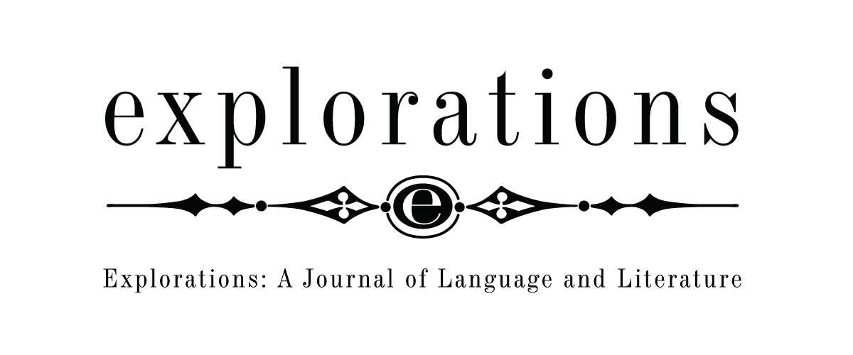 | Explorations: A Journal of Language and Literature  Opole University  Pl. Kopernika 11, 45-040 Opole,  POLAND  http://www.explorations.uni.opole.pl  explorations@uni.opole.pl

Review Form
Paper Title

Paper Code

Please rate the paper on the scale from 5 (excellent) to 0 (unsatisfactory) for the following categories and answer additional questions choosing yes or no and shading the selected answer. Please add comments if your overall rating is lower than 4.

Clarity:

Excellent | Very Good | Good, minor changes needed | Poor, major changes needed | Very poor, re-writing needed | Unsatisfactory
5 | 4 | 3 | 2 | 1 | 0

Is it clear what was done?
Is it clear why it was done?
Is the structure logical?
Is the theoretical background clearly described?

Correctness:

Excellent | Very Good | Good | Poor | Very Poor | Unsatisfactory
5 | 4 | 3 | 2 | 1 | 0

Is the theoretical background appropriate?
Is the methodology appropriate?
Are the data presented in an appropriate way?
Is the language appropriate?

Implications:

Excellent | Very Good | Good | Poor | Very poor | Unsatisfactory

Is the topic selected relevant / worth investigating?
Are the results important for the field?
Is the paper likely to inspire further work in the field?

Originality:

Excellent | Very Good | Good | Poor | Very poor | Unsatisfactory

Is the approach new?
Is the content new?

Overall Score:

Excellent | Very Good | Good, minor changes needed | Poor, major changes needed | Very poor, re-writing needed | Unsatisfactory
5 | 4 | 3 | 2 | 1 | 0

Your comments:
If you think that changes are needed, please, specify exactly what should be revised.

