Name
Affiliation
ORCID

A Title of an Article Submitted to Explorations: A Journal of Language and Literature

Abstract. A short abstract (summary) of your contribution should be inserted here. Use short, direct sentences. It should be as concise as possible. It should be complete, self-explanatory and should not require reference to the paper itself. The abstract should be informative, giving the scope and emphasizing the main conclusions, results, or significance of the work described. It should be between 100-150 words.

Key words. Articles should be accompanied with up to six words referring to key concepts discussed in the paper.

1. Introduction
Joshua Weinstein (2009) in a paper on . . . [commonest version]. Later, Weinstein (2009, 440) adds that . . . [upon first mention in the text, use an author’s full name; thereafter, use the last name only].
Long citation long citation long citation long citation long citation long citation long citation long citation long citation long citation long citation long citation long citation long citation long citation long citation long citation long citation long citation long citation long citation long citation long citation long citation long citation long citation long citation long citation long citation long citation long citation long citation long citation long citation long citation long citation long citation long citation long citation long citation long citation long citation

2. Section title
Mendelsohn (2010, 68) states that ... [where page number is required]. Kossinets and Watts (2009, 411) also claim that . . . . Evidence is given by Barnes et al. (2010) . . . [for three or more authors].
Further exploration of this aspect may be found in many sources (e.g. Choi 2008; Kamp 2006, Stolberg and Pear 2010) [note alphabetical order, use of ‘and’ and semi-colons].
According to Pollan (2006, 99–100), it is essential that … . The same study invalidated this hypothesis (Ward and Burns 2007, 52). In a preface written by Rieger (1982, xx-xxii), one may read that . . . ; the research material used in this study is Austen (2007). This information is also available online (Google 2009; McDonalds 2008).
In a text message to the author on March 1, 2010, John Doe revealed that . . . Descriptive statistics (Table 1) describe linguistic data in quantitative terms.

Description of data | Column1 | Column2
Number of running words | 289,574 | 252,309
Number of word tokens | 289,332 | 251,500
Number of word types | 19,784 | 16,211

Table 1. Description of Table 1

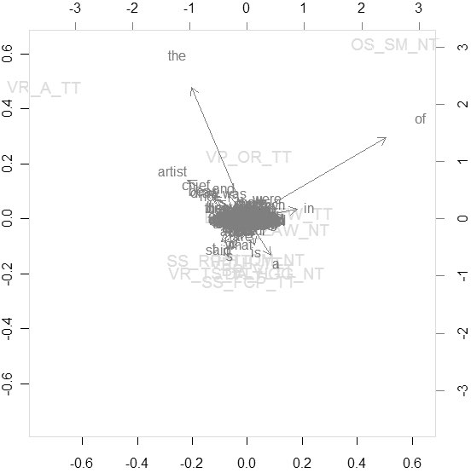
Figure 2. Description

3. Conclusions
The study can be extended in the future also by … (John Doe, pers. comm.).

References [Follow Chicago Manual of Style, 16th edition (2010)]
Adelman, Rachel. 2009. “ ‘Such Stuff as Dreams Are Made On’: God’s Footstool in the Aramaic Targumim and Midrashic Tradition.” Paper presented at the annual meeting for the Society of Biblical Literature, New Orleans, Louisiana, November 21–24.
Austen, Jane. 2007. Pride and Prejudice. New York: Penguin Classics. Kindle edition.
Choi, Mihwa. 2008. “Contesting Imaginaires in Death Rituals during the Northern Song Dynasty.” PhD diss., University of Chicago.
Choi, Mihwa. 2008. “Contesting Imaginaires in Death Rituals during the Northern Song Dynasty.” PhD diss., University of Chicago. ProQuest (AAT 3300426).
Cicero, Quintus Tullius. 1986. “Handbook on Canvassing for the Consulship.” In Rome: Late Republic and Principate, edited by Walter Emil Kaegi Jr. and Peter White. Vol. 2 of University of Chicago Readings in Western Civilization, edited by John Boyer and Julius Kirshner, 33–46. Chicago: University of Chicago Press. Originally published in Evelyn S. Shuckburgh, trans., The Letters of Cicero, vol. 1 (London: George Bell & Sons, 1908).
García Márquez, Gabriel. 1988. Love in the Time of Cholera. Translated by Edith Grossman. London: Cape.
Google. 2009. “Google Privacy Policy.” Last modified March 11. http://www.google.com/intl/en/privacypolicy.html.
Kamp, David. 2006. “Deconstructing Dinner.” Review of The Omnivore’s Dilemma: A Natural History of Four Meals, by Michael Pollan. New York Times, April 23, Sunday Book Review. http://www.nytimes.com/2006/04/23/books/review/23kamp.html.
Kelly, John D. 2010. “Seeing Red: Mao Fetishism, Pax Americana, and the Moral Economy of War.” In Anthropology and Global Counterinsurgency, edited by John D. Kelly, Beatrice Jauregui, Sean T. Mitchell, and Jeremy Walton, 67–83. Chicago: University of Chicago Press.
Kossinets, Gueorgi, and Duncan J. Watts. 2009. “Origins of Homophily in an Evolving Social Network.” American Journal of Sociology 115:405–50. Accessed February 28, 2010. doi:10.1086/599247.
Kurland, Philip B., and Ralph Lerner, eds. 1987. The Founders’ Constitution. Chicago: University of Chicago Press. http://press-pubs.uchicago.edu/founders/.
Lattimore, Richmond, trans. 1951. The Iliad of Homer. Chicago: University of Chicago Press.
McDonald’s Corporation. 2008. “McDonald’s Happy Meal Toy Safety Facts.” Accessed July 19. http://www.mcdonalds.com/corp/about/factsheets.html.
Mendelsohn, Daniel. 2010. “But Enough about Me.” New Yorker, January 25.
Pollan, Michael. 2006. The Omnivore’s Dilemma: A Natural History of Four Meals. New York: Penguin.
Posner, Richard. 2010. “Double Exports in Five Years?” The Becker-Posner Blog, February 21. http://uchicagolaw.typepad.com/beckerposner/2010/02/double-exports-in-five-years-posner.html.
Rieger, James. 1982. Introduction to Frankenstein; or, The Modern Prometheus, by Mary Wollstonecraft Shelley, xi–xxxvii. Chicago: University of Chicago Press.
Stolberg, Sheryl Gay, and Robert Pear. 2010. “Wary Centrists Posing Challenge in Health Care Vote.” New York Times, February 27. Accessed February 28, 2010. http://www.nytimes.com/2010/02/28/us/politics/28health.html.
Ward, Geoffrey C., and Ken Burns. 2007. The War: An Intimate History, 1941–1945. New York: Knopf.
Weinstein, Joshua I. 2009. “The Market in Plato’s Republic.” Classical Philology 104:439–58.

First Contributor’s Bio: On a separate page of your manuscript, please provide a biographical note of fewer than 100 words containing your rank, affiliation, specialization, and most significant publications or current research. Include publication dates for all books.

E-mail address: firstauthor(at)server.com

Second Contributor’s Bio: On a separate page of your manuscript, please provide a biographical note of fewer than 100 words containing your rank, affiliation, specialization, and most significant publications or current research. Include publication dates for all books.

E-mail address: secondauthor(at)server.com

